**Key Stage 1 - Statutory requirement of subject content**

**Pupils should be taught to:**

* use their voices expressively and creatively by singing songs and speaking chants and rhymes
* play tuned and untuned instruments musically
* listen with concentration and understanding to a range of high-quality live and recorded music experiment with, create, select and combine sounds using the inter-related dimensions of music.



**Key Stage 2 - Statutory requirement of subject content**

**Pupils should be taught to sing and play musically with increasing confidence and control. They should develop an understanding of musical composition, organising and manipulating ideas within musical structures and reproducing sounds from aural memory.**

Pupils should be taught to:

* play and perform in solo and ensemble contexts, using their voices and playing musical instruments with increasing accuracy, fluency, control and expression
* improvise and compose music for a range of purposes using the inter-related dimensions of music
* listen with attention to detail and recall sounds with increasing aural memory
* use and understand staff and other musical notations
* appreciate and understand a wide range of high-quality live and recorded music drawn from different traditions and from great composers and musicians
* develop an understanding of the history of music.

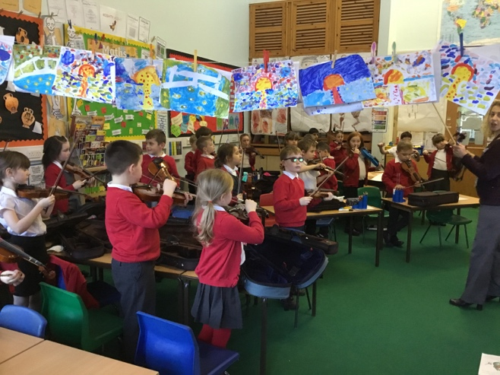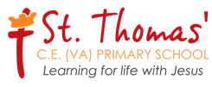

**Music Policy**

**Introduction**

At St Thomas’ CE(A) Primary School, we provide all children with equal opportunities to develop their knowledge and understanding of music, appropriate to their age and ability, regardless of gender, race, religion, cultural diversity and special needs of all kinds. We aim to inspire pupils to develop a love of music, increasing self-confidence, creativity and sense of achievement.

**Rationale**

A high-quality music education should engage and inspire all pupils to develop their God-given love of music and their talent as musicians, and so increase their self-confidence, creativity and sense of achievement. Music has the potential to make a significant contribution to children’s development: increasing confidence and self-esteem, developing leadership, team working, concentration and problem-solving skills, and developing identity and improving social cohesion within the school and wider community as well as providing opportunities to celebrate success.

**Aims**

Our music curriculum aims:

* To foster pupil's enjoyment and thankful appreciation of music and to develop self esteem through musical achievement.
* To develop personal and social and learning skills which transfer across the curriculum through participation in a wide variety of musical activities and performances.
* To ensure through structured musical activities, the development of musical skills, knowledge and understanding.
* To encourage pupils to take an active and creative part in all aspects of music (composing, performing, listening and appraising.) including celebrating their achievements.
* To foster pupil's appreciation of music of different styles, times and cultures.
* To ensure equality of opportunity for all, considering each pupil’s experience, abilities and needs. Our curriculum should be fair to all.
* To support children’s emotional, physical, imaginative, social and intellectual development through music.
* To allow children to express, explore, represent and communicate ideas and perceptions in an environment where they trust each other and feel safe.

**Extra-Curricular and Off-Site Opportunities**

Extra curriculum time is taken when there is a special show or performance to work for. Key stage two offers opportunities for a variety of extra curricular musical activities and clubs (choir, signing club, street dance) as well as instrumental tuition. Year 3 children learn the violin and year 5 learn how to play a brass instrument. Concerts are performed for parents at the end of the year. The choir perform at events throughout the year and visit care homes to sing to the residents. They also travel for young voices.

**Differentiation**

Differentiation is identified on weekly plans if appropriate and should include support for below average attainers and\or ISP children to enable them to study the same key question or line of enquiry as other pupils. Examples of this include the use of modified resources, a narrower range of information or adult support to facilitate learning. More able pupils should be challenged to raise achievement and may be expected to use and interrogate more demanding skills and analyse and communicate ideas at a greater depth, often using higher order literacy skills. Teachers use a range of teaching styles to match the different learning styles represented in a typical class.

**School Curriculum Planning Themes Cross-Curricular**

Music is taught weekly during discrete lessons. Some lessons will be taught by specialist music teachers or provision from the county music service. Wherever possible, links will be made to curriculum areas including science, , art, DT, literacy, geography and history. Planning includes opportunities to teach knowledge and key skills in music, the use of ICT where appropriate and the promotion of PSHE skills and speaking and listening. Generic learning skills involving thinking, creativity, evaluation and independence are also promoted wherever appropriate.

Efforts have been made to capitalise on links between the music curriculum and literacy by planning for children to read widely, develop and use speaking and listening in activities such as evaluating performances and to communicate music knowledge and understanding.

**Assessment**

Assessment is always linked to National curriculum objectives and children will be judged as either unable to access the curriculum (PKS), working towards, at the expected level or working at greater depth. Pupil progress is reported to parents at the end of the school year. • Pupils are encouraged to comment on and evaluate their own and each other’s performances to aid self-assessment and improvement. Teachers will identify individual strengths and talents and guide children towards clubs/activities that will extend attainment further.