Phase 3 activities to do at home
By phase 3, children will already know a lot of phonemes (sounds) but this phase introduces the remaining, more difficult, phonemes such as /ch/ and /ow/. By the end of phase 3, children should be able to say the sound for all, if not most, phase 2 and 3 graphemes. They should also be able to blend words made from these graphemes for example /ch/ + /air/ = chair. More tricky words are also learnt at this stage including ‘was’, ‘my’ and ‘you’. Here are some activities that can be completed at home to further develop your child’s phonic skills.
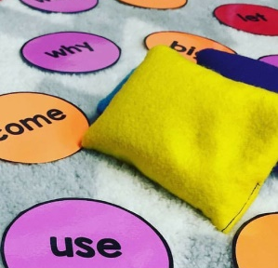
To practise learning how to read and spell tricky words you can play games such as these below with your child;
- Rainbow spellings – writing out the tricky words in different colours, funky writing and making patterns.
- Bingo – choose 4 of the tricky words and then play bingo.
- What is the tricky word? Write out the tricky words individually on pieces of paper and then scatter them on the floor (outside or in a big space) and use a bean bag or piece of equipment that you can safely throw and try to land on the words laid out on the floor. Once the child has caught the word they can read it to you.
- Can you find the tricky word? An adult could stick the tricky words on pieces of paper around the house/room and the children have to go and find them and then read them out to the adult correctly.
- What is it? Tricky words could be placed in a bag or a box and then children or an adult can pick one out at a time and have a go at reading it. If they get it correct they can keep it, if not they put it back in the bag/box.
- Pairs Two sets of tricky words can be placed upside down and the children have to pick one at a time, read it aloud and then find the matching pair.
To practise learning the phonemes, you can play games such as these below with your child;
- Use the phoneme sound mats (found on the school website) to quick flash the phonemes to see which ones your child knows and practise the ones they don’t.
- How many? – Give your child a phoneme they know already for example; /ch/ and see how many words they know that contain that phoneme.
- What is the sound? – Write out the phonemes your child knows and possibly the ones they don’t know on a piece of paper or a post it note. Place the piece of paper outside in the garden or in spare place in the house and use a counter/beanbag/soft toy that your child can safely throw at the piece of paper and saw the phoneme correctly. If your child gets it right they get to keep that phoneme.
- SPLAT! – using the phoneme cards similar to the last game note down all the phonemes for this phase from the phoneme mat on the website. You need to say aloud one of the phonemes that has been placed down and your child needs to splat the one they think you have said. If your child gets it right they get to keep that phoneme.
Here is a useful site to use to listen to the individual phonemes - Phase 3 phonics - KS1 English - BBC Bitesize

