Phase 2 activities to do at home
Phase 2 is the when children are first introduced to phonemes (the sounds that letters make). In total, there are 44 sounds, a mixture of one letter and two letter sounds. By the end of Phase 2, children should be starting to read and may also be able to spell consonant – vowel – consonant words (e.g. sat, tap) as well as some tricky words such as ‘the’ and ‘go’. Here are some activities that can be completed at home to further develop your child’s phonic skills.
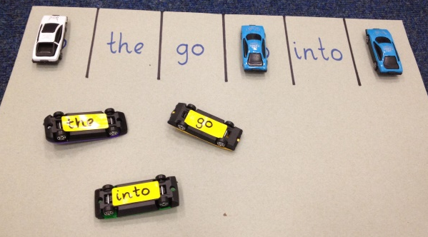
To practise learning how to read and spell tricky words, you can play games such as these below with your child;
- Rainbow spellings – writing out the tricky words in different colours, funky writing and making patterns.
- Bingo – choose 4 of the tricky words and then play bingo.
- What is the tricky word? Write out the tricky words individually on pieces of paper and then scatter them on the floor (outside or in a big space) and use a bean bag or piece of equipment that you can safely throw and try to land on the words laid out on the floor. Once the child has caught the word they can read it to you.
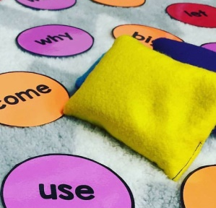
- Can you find the tricky word? An adult could stick the tricky words on pieces of paper around the house/room and the children have to go and find them and then read them out to the adult correctly.
- What is it? Tricky words could be placed in a bag or a box and then children or an adult can pick one out at a time and have a go at reading it. If they get it correct they can keep it, if not they put it back in the bag/box.
- Pairs Two sets of tricky words can be placed upside down and the children have to pick one at a time, read it aloud and then find the matching pair.
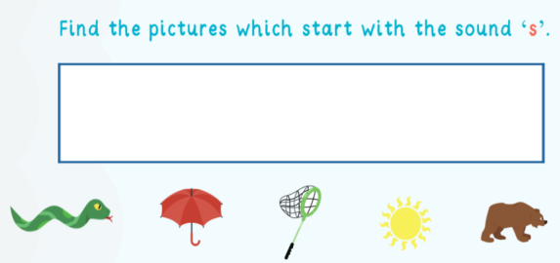
To practise learning the phonemes, you can play games such as these below with your child;
- Use the phoneme sound mats to quick flash the phonemes to see which ones your child knows and practise the ones they don’t.
- Get some images or objects from around the house that start with the chosen phoneme (also get some that don’t just to mix in) then get the children to pick the images/objects that start with that sound.
- Eye spy. I spy with my little eye something beginning with T…
- Using toys the children already have (lego is good for this) to record the phonemes on which they can then explore what CVC (consonant –vowel –consonant) words they can make from the letters they know.

