School uniform policy
2021/2022

The Governors require all children in St Thomas’ school to adopt the school code of dress which is out-lined below.

We, at St Thomas’, are proud of our school uniform and aim to ensure that we have a cost effective, smart representation of the high standards we uphold.

Aims and objectives
Our policy on school uniform is based on the belief that we are proud to wear a uniform that:
- Promotes a sense of pride in our school
- Helps to create a sense of community and belonging towards the school
- Identifies pupils with the school
- Supports the school’s commitment to inclusion
- Prevents pupils from wearing ‘fashion clothes’ that could be distracting in class
- Is practical, smart, and designed with health and safety in mind
- Is considered to be good value for money

The Role of Parents
We believe that one of the responsibilities of parents is to ensure that their child has the correct uniform and PE kit; that it is clean, in good repair and that the child’s name is visibly labelled on all items. If a parent has difficulties for any reason with fulfilling this request, they are asked to speak confidentially to a senior member of staff to discuss the issues. Parents should be assured that we will do all we can to help.

The school welcomes children from all backgrounds and faith communities. If there are serious reasons, for example on religious grounds, why parents want their child to wear clothes that differ from the school uniform, the Uniform Policy will consider such requests sympathetically. If any parent would like to request an exception to the uniform policy they should, in the first instance, contact the Principle and then the
Governors.

The role of Governors
The governing body supports the headteacher in implementing the school uniform policy. It considers all representations from parents regarding the uniform policy and liaises with the Principle to ensure that the policy is implemented fairly and with sensitivity. It is the governors’ responsibility to ensure that the school uniform meets all regulations concerning equal Monitoring and Review opportunities. Governors ensure that the school uniform policy enables children to dress sensibly, in clothing that is hardwearing, safe and practical.

Monitoring and review
The governing body monitors and reviews the school uniform policy through its committee work by:
- seeking the views of parents, to ensure that they agree with and support the policy;
- considering, with the Principle, any requests from parents for individual children to have special dispensation with regard to school uniform.

Our school uniform expectations

- Red sweatshirt, jumper or cardigan
- White polo shirt
- Grey trousers, skirts or a pinafore
- Sensible flat black school shoes – NOT trainers or pumps
- Summer dresses in red gingham/ grey shorts
- Plain black socks (boys) or grey tights/ white socks (girls)

Our P.E. uniform expectations
In addition, this year, and in response to Covid restrictions, classes have trialled wearing PE uniform for the whole day when taking part in physical education. We have found this to be a great success; the children have had less disruption to their day and have had more time to engage in physical education. In light of this, we have decided to continue with this moving into the next academic year. Please be reminded that the PE kit is part of our school uniform and as such, it is expected that the correct attire will be worn at all times.
On PE days, the children need to wear the following:

- Plain white t-shirt/ polo shirt ( football tops are not permitted)
- Plain black shorts/skorts
- Plain black trainers (MUST be different to normal school shoes)
- Plain black jogging bottoms/ leggings

Whilst we would prefer pupils to wear uniform with the school logo on, we understand that some families would prefer the option of wearing plain items of clothing. This is perfectly acceptable providing the uniform is the same colour and style as the logo uniform.
We strongly encourage your child’s name to be clearly written on the inside labels of all items of clothing.

Additional
Coat | Coats must be taken off in all buildings
Hair | For all years, hair should be cut appropriately for school and of a natural colour
Hats | Hats may only be worn outside the school building
Water bottle | Essential. Must be clearly named.

Footwear
Buying the correct footwear can also be problematic. Our policy is that footwear must be black leather or leather in appearance and laces must also be black. Sportswear shoes are NOT allowed. These will usually have some form of canvas or logo on them. Please contact the school before purchasing footwear if you are unsure.
These are some examples of unacceptable footwear.

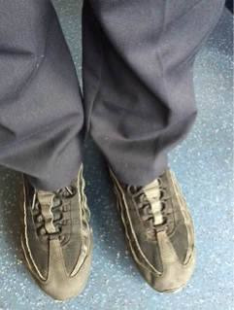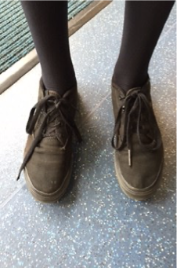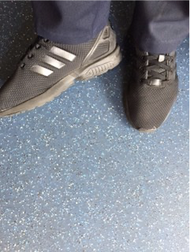

Swimming Kit (KS2)
In year 4, pupils receive an hour swimming lesson a week. On these days, pupils will require:
- One-piece costume (no bikinis),
- Swimming trunks (no swimming shorts)
- A cap
- A towel

Jewellery
For health and safety reasons jewellery should not be worn.

If pierced earrings have to be worn they should be small studs and should be removed at home on days when the child will be doing PE, dance or swimming.

No necklaces, rings, bracelets or other items that adorn the body should be worn. Sensible watches may be worn at the discretion of parents, but the child must take responsibility for looking after his/her watch.

Watches that make noises or are playthings should not be brought to school as they are distracting in lessons.

If the children wear a ‘Smart Watch’ these must not be able to receive messages or cause a distraction.
Hair accessories should be sensible and in keeping with school wear (i.e small head bands or bobbles), children with long hair should wear it tied up.

Hairstyles
Hairstyles should be suitable for school (no extreme haircuts (including patterns shaved into hair), long hair should be tied up, and all hair colours should be of a natural colour.

Head coverings/articles of Faith
We are aware that for many faiths and cultures, head coverings are not mandatory for primary age children and parents may delay their use until their child attends high school. Where this flexibility for delay exists, we would respectfully ask parents to send their child to school without a head covering. Where a faith group specifically mandates an article of faith to be worn then this will be respected unless any health and safety issues arise that cannot be reasonably resolved.

Nail varnish
Nail varnish should not be worn for school.

Breaching the school uniform policy / non-compliance
It is the principle’s responsibility to make sure pupils keep to the rules.
As part of our policy around uniform standards, we will employ a strategy of consequences to maintain our high expectations, which will involve:

First strike | - Any child who is not wearing the correct uniform and teachers have not been informed (via a note/ phone call), will be spoken to discretely by the teacher. Uniform expectations to be reiterated.  - Teacher to send a message on WEDUC that day to remind parents of the uniform policy.
Second strike | - Teacher to speak to child as above.  - Teacher to catch parents at the end of the day/ call home to discuss/ remind parents of uniform policy
Third strike | - Teacher to speak to child as above.  - Parents invited into school for a meeting with an SLT member. SEN team to be informed.

Purchasing school uniform
School uniform is available from the National School Supplies shop in Stafford Street, Hanley, or you can order it online at:- www.smartacademyuniform.co.uk.
We recognise the financial implication of purchasing uniform for children who grow so quickly and are often quick to get through it. With this in mind we recycle good quality school uniform which is available from the school office. This will enable all families to provide uniform for their children. Please contact the school should you want further information on this.

