Phase 1 activities to do at home
Phase 1 is the beginning of the phonic phases. In this stage, children begin to build on their listening and speaking skills which begins in nursery at pre-school level. Throughout Phase 1, children are taught sounds, both environmental and instrumental, and spend time exploring body percussion (e.g clapping). They learn rhythm and rhyme, alliteration as well as start to orally blend and segment. For example, they hear that c – a – t makes ‘cat’. To practise this phase, you can play games such as these below with your child;
Environmental sounds
- Go on a listening walk around the garden or an outside area with an adult and listen carefully to the sounds you hear. Do you recognize the sounds? Are they loud or quiet?
- Play the game ‘I hear with my little ear’. Take it in turns to imitate the sound of something, for example; the ticking of the clock, a telephone, an animal etc and the other person guesses what makes that sound.
Instrumental sounds
- If you have any musical instruments at home you could play a sound and your child could copy it, try making sounds themselves and they could even perform a musical show!
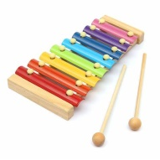
Body percussion
- You could clap along to the beat of songs on the radio.
- Play ‘follow the leader’ as a family, the leader chooses some body percussion; clapping, patting their knees, clicking their fingers etc and the rest of the family have to copy them, but don’t forget to take it in turns to be the leader!
Alliteration
- You could go on a letter sound hunt and find something in the house beginning with a letter they know. Can you find something beginning with‘s’?
- If your child has any animal toys or you could get pictures of some animals and try to give them names that start with the same letter as the animal, Tony the turtle etc.
Rhythm and Rhyme
- Singing rhymes at home they the children already know from school or home or you could learn a new one!
- Which is the odd one out? An adult can say a list of some words and the child needs to find the odd one out (the one that doesn’t rhyme) for example; three, tree, nose, bee.
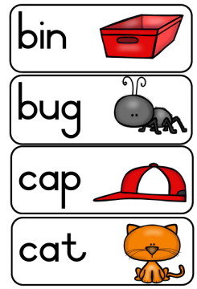
Oral blending and segmenting
- An adult could sound out some simple words for their child to listen to; tap, net, pin, mat and see if your child can count on their fingers how many letter sounds are in each word – t/a/p = 3 letter sounds for tap.
- Listening and drawing game. A grown up can sound out a word by saying the letter sounds and the child has to draw the item – /c/ + /a/ + /t/. Did they know the word their grown up was sounding out? Were they able to blend it together? C + a + t = ca

