Phase 5 activities to do at home
Phase 5 is as fundamental part of phonics and normally takes children the whole of year 1 to complete. Children continue to explore digraphs (two letters that make a single sound) and trigraphs (three letters that make a single sound) however, they begin to notice that some of these can make different sounds in different words. For example, the diagraph /ow/ makes a different sound in ‘cow’ and ‘show’. Also, one sound can have alternative spellings for example; ‘rain’ and ‘pay’ - both contain the same sound but are spelt differently /ai/ and /ay/. Children will start to choose the right graphemes when spelling and will learn more tricky words.
To practise learning how to read and spell tricky words you can play games such as these below with your child;
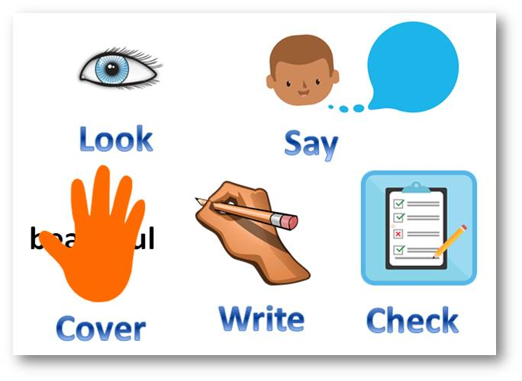
- Rainbow spellings – writing out the tricky words in different colours, funky writing and making patterns.
- Bingo – choose 4 of the tricky words and then play bingo.
- Say it, cover it, write it - To support spelling more tricky words this is a quick game you can play with your child by giving them the tricky word wrote down, they say it aloud, either you cover it or they do and then they write it down 3-5 times. You could add the element of timing to the game or have a go yourself to encourage your child further.
- Can you find the tricky word? - An adult could stick the tricky words on pieces of paper around the house/room and the children have to go and find them and then read them out to the adult correctly.
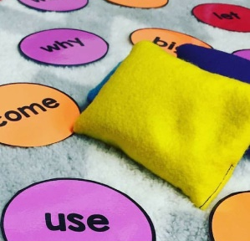
- What is it? - Tricky words could be placed in a bag or a box and then children or an adult can pick one out at a time and have a go at reading it. If they get it correct they can keep it, if not they put it back in the bag/box.
- Pairs - Two sets of tricky words can be placed upside down and the children have to pick one at a time, read it aloud and then find the matching pair.
To practise learning the phonemes, you can play games such as these below with your child;
- Flashlight Hunt – write the phonemes for this phase on pieces of paper and tape them around a room. Turn out the lights and have your child shine a flashlight, once they come across a phoneme card they need to say it aloud and then they can collect the phoneme as a prize.
- SPLAT! – write down all the phonemes for this phase from the phoneme mat on the website. You need to say aloud one of the phonemes that have been placed down and your child needs to splat the one they think you have said. If your child gets it right they get to keep that phoneme.
- High five – This is a good game for them phonemes they just can’t quite get! You and your child can draw around their hand and cut out a number of handprints – enough for the amount of phonemes they are unsure about. Write one of the phonemes on each handprint and stick them around the house. If you child can say the phoneme they can give the handprint a high five!

