Phase 4 activities to do at home
Before children progress onto phase 4, they should be confident with each phoneme in the English language. Phase 4 really concentrates on reading and spelling CVCC words (e.g. bump, milk, bent) words that have consonant+ vowel+ consonant+ consonant, high frequency words, sentences and more tricky words. Children at this stage should be able to write every letter; they may even be able to read some words aloud without needing to sound them out.

As you do not learn any new phonemes in Phase 4, it is a great time to practise your child’s blending and segmenting of words using the phonemes they do know from phase 1 - 3. Here are a few ways you can practise having a go at spelling CVCC words and reading tricky words at home.

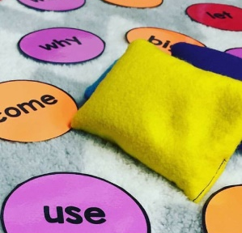
- Rainbow spellings – writing out the tricky words in different colours, funky writing and making patterns.
- Bingo – choose 4 of the tricky words and then play bingo.
- What is the tricky word? Write out the tricky words individually on pieces of paper and then scatter them on the floor (outside or in a big space) and use a bean bag or piece of equipment that you can safely throw and try to land on the words laid out on the floor. Once the child has caught the word they can read it to you.
- Can you find the tricky word? An adult could stick the tricky words on pieces of paper around the house/room and the children have to go and find them and then read them out to the adult correctly.
- What is it? Tricky words could be placed in a bag or a box and then children or an adult can pick one out at a time and have a go at reading it. If they get it correct they can keep it, if not they put it back in the bag/box.
- Pairs Two sets of tricky words can be placed upside down and the children have to pick one at a time, read it aloud and then find the matching pair.
- Reading with your child regularly is great practise for segmenting and blending, maybe even having a go at books that aren’t their level books from school.
- Speedy spellings - This game has the excitement of time. You can choose a spelling (a tricky word perhaps) and write it down on a piece of paper. Let your child look at it, read it, remember it, then take the word away. See how many times your child can write the word they’ve just seen in a note book or a on a piece of paper in 10 seconds, 15 seconds or even 5 seconds if they’re really speedy!
- Do you know the word? – Have a list of CVCC words in front of you (I have included a list at the bottom of this document) and sound out the word to your child slowly, emphasising each phoneme, for example; t – e – n – t. See if they can blend the sounds you are saying together to form the word and write it down.
tent lamp nest pond hand sink chest sand coin ring

Here is a video to support you and your child: Phonics: How to blend sounds to read words | Oxford Owl - YouTube

